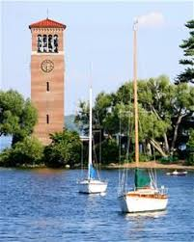

**ZONTA DAY at CHAUTAUQUA**

***Please join us on the beautiful grounds of Chautauqua Institution, for a day of learning, reflecting, and friendship!***

You’re invited to spend August 16th with the ***Zonta Club of Jamestown***

The Day’s Agenda:

8:45am - 10:30am – Registration at Visitors Center

9:15 am – Prayer Service - Rev. Dr. Mary Luti, Pastor and Teacher, United Church of Christ

(this is not our main lecture, however, you are welcome to attend) ***Amphitheater***

10:45 am – Tarana J. Burke, Founder, “Me Too” Movement – Began her professional life in Selma; co-founded Just Be Inc. organization; realizing how many were

suffering through abuse without access to resources, safe spaces and support, the “Me Too” Movement was born out of this need. ***Amphitheater***

12:15pm – Lunch at LaFamilia Restaurant, located on lower level of the ***St. Elmo***

2:00pm - Arvind-Pal S. Mandair -teaches at the University of Michigan; Associate Professor

in Sikh Studies, Department of Asian Languages and Cultures. ***Hall of Philosophy***

8:15pm – An Evening with Dawes (tickets can be purchased separately) ***Amphitheater***

Please browse the Chautauqua website at [www.ciweb.org](http://www.ciweb.org) for details on all that

Chautauqua has to offer while you are on the grounds.

Cost: $60(US) $80(Can) Includes All Day Gate Pass from 7:00am to 8:00pm, lunch, and speakers.

($25 for Gate Pass Holders) Parking is additional $10. *We have secured 2 places nearby to*

*park ‘n ride if you want to save $$ and carpool. (Ask for details)*

***Return form with payment:***

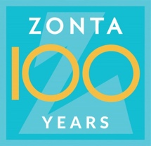

**************************************************************************************************

**Registration Form** Zonta Club of _______________________

Name: ______________________________________ Address: __________________________________________

City/State/Zip_________________________________ Phone: ___________________________________________

Email: ____________________________________

Please include check payable to **Zonta Club of Jamestown**, mail to: Mary Rappole, 4541 Chautauqua Stedman Rd., Mayville, NY 14757

Call or email Mary Rappole @ 716-499-4467 [maryrappole@gmail.com](mailto:maryrappole@gmail.com) or Karen Dolce @ 716-665-9355 [kldolce@gmail.com](mailto:kldolce@gmail.com) with any questions.

*Deadline to register: August 9th