The Zontiana
Special Conference Edition Fall 2017

Rundown of the conference:
Our Zonta International President is Sonja Honig Schough
Our Zonta International representative was Board Director, Judith Anderson OAM from Australia
Our District 4 Governor is Lori Robinson
There were 123 registered persons for the conference and 121 persons in attendance
We had zero clubs go unrepresented!
We went over budget, proposals and voting was swift and eased with the use of Robert's Rules of Order (which I'm still learning).
We heard various club and area reports; heard from our scholarship recipients for the Jane M. Klausman, Young Women in Public Affairs and Amelia Earhart awards. We were called to Convention in Japan in 2018, and conference in 2019 in Buffalo by our Lieutenant Governor, Bonnie Clesse. The various committees from District 4 gave their updates.
- District 4 Foundation Ambassadors Report
- Memberhip Committee
- Amelia Earhart Committee Report (We raised $3,000 at Conference - including the baskets)
- Risk Management Committee
- United Nations Committee
- Advocacy Committee
- Bylaws Committee
- Nominating Committee
- Centennial Committee
- Z Club Report
**If you're interested in reading the reports, please see Rosie for a copy of her program.
Rules of Procedure Voting:
All matters put before the membership via email June 27th, 2017, regarding the rules of procedure, were passed. Among the changes were adjustments to the language in the by-laws, number of workshops, clarification regarding campaigning for offices held in Zonta and adjustment to the district dues.
Regarding $8 Dues Increase:
Our club Finance committee will review the $8.00 increase in dues and bring their suggestion to the board, and then to membership, for a vote.
Memorial Service:
The memorial service we planned for the conference was well received. Each of us took an active role in the service and Zontians from other clubs commended us on our sincere and respectful approach to honoring the members who had passed in the last biennium.
Feedback on Birthing Kits:
Suggestion was brought to the conference that we put the soaps in a small baggie to protect the other items in case of heat or melting of the soaps.
Notes from Sunday morning panel discussion:
Representatives spoke to conference attendees from Savis of Halton, Peel Region, Ontario.
Savis is a domestic violence and trafficking recovery home.
They've received committment from 47 agencies
They are a resource.
Process map of services available with in first 24-48 hours.
"Are you the one?" posters to identify exploited behaviors or signifiers of human trafficking.
"We believe survivors!" mantra
There are three groups to help:
- Victim
- Service Providers
- Parents
Agencies in ON engage in "train the trainer" and gives instruction to schools, hotels, agencies, women's detention center and more.
Also heard from Kris Noakes, PAN, who discussed indigenous women's danger of trafficking. There are 4,000 missing women from the area alone. Friendship Centers on reservations are good places to learn more about indigenous women and to learn about their culture and how to help. "Mig-witch" is Thank you in their language.
Idea to put together kits for trafficked women: Chocolates, hair ties, socks, small bag of items to give to them so they know they arne't alone.
**Ever heard of credit carding? Rainbow Party? Spin the bottle? All three are ways children/people can be exploited sexually.
Service Recognition Awards:
Clubs are encouraged to apply for the award if they have a service project that fits the following criteria.
- Empowerment of girls
- Prevent violence against women and girls
- Must benefit above, be credible and sustainable
Due date for nominations Nov. 15th 2017
Cannot apply for it if already applied for it. Look for rules and application online at membership.zonta.org/service tools
Zonta District 4 finances can be found on website: ZontaDistrict4.org
Note from D4 Membership Committee
"Zonta International membership committee has worked hard to prepare as much help for us as possible. Their information on Zonta.org is very comprehensive - covering probably anything you want to know." Remember, professionals under 30 who would like to join, can do so at a lesser $ rate. See Zonta.org for details on the Young Professionals rate.
************************
There were four workshops at conference:
- What Gets Measured, Gets Done! by Karen Grant (Notes from Julie Dudgeon)
- Advocacy. If not now, when? by Ellen Blahitka, Mary Vacanti, Pati Aine Guzinski
- Zonta 101 and Protocol by Janis Durmis (Notes from Rosie Papalia)
- Navigate the ZI Website by Katherine Cleland-ZI Communications & Sandra Cronk (Notes from Laura Corey)
Our Jamestown members split up the workshops so we could each do a report on what was said/done at each.
Rosie's Notes on "Zonta 101 and Protocol" by Janis Durmis
Janis Durmis is our Area 5 Director (See map to figure out her footprint). She is AD until June. She put together a great power point presentation outlining Zonta's mission, vision, logo explained, history and structure. Janis also explained meetings from top: Zonta International Convention, to Zonta International President -> Zonta Districts -> Areas, clubs and regions. Zonta's schedule runs terms monthly, quarterly, yearly and by biennium. We use Robert's Rules of Order for meetings and the take away from this 101 should be the power of one vote. When you attend club, conference and conventional meetings, you can vote and be informed.
Janis explained dues structure: each club varies (See our roster for our breakdown), and dues typically go toward service programs and awards like Amelia Earhart, Jane M. Klausman and YWPA. Two such international projects our dues fund are: 1. elimination of obstetric fistula and reduction of maternal and newborn mortality in Liberia and 2. 'Let us learn Madagascar', the integrated project for adolescent girls. ZISVAW projects in Niger and Nepal to reduce childhood marriage and human trafficking (see zonta.org for more info).
On the Zonta International Board there are 4 officers and 7 Board of Directors.
Information specific to clubs:
Clubs must have a minimum of 20 members to be chartered. Members of the club select the President, VP, Secretary, Treasurer and Board of Directors. Attendance is important to learn, engage and advocate. Clubs must have a quorum to pass a vote.
All clubs must have these committees: service, advocacy, membership & classification, and nominating.
Optional committees could include: bylaws, archives, program and scholarships
Benefits to membership: networking, advocacy, travel, excitement and experience
Pin Protocol: Name tag on left, pins on right - international membership pin worn over heart.
For more information about the above, please feel free to view Zonta.org.
Strategic Planning Workshop: Julie Dudgeon
Area 2 Director, Karen Grant, led this discussion. She began by defining the difference between “vision,” highest expectations, and “mission,” club business and how to achieve desired programs and goals.
Analysis based on SWOT: Strengths – Weaknesses – Opportunities – Threats, helps determine collective vision.
Clubs directions need to be SMART: Specific – Measurable – Achievable – Relevant – Timely. (Example: Oakville decided to increase its service events by 50% in the second half of the biennium.)
Multi-year goals are also a possibility by setting goals over a two-year period. (Example: Oakville determined it would raise funds over two years to support a new vehicle for a local non-profit.)
Ideas for strategic planning:
*Succession planning
*Increase membership
*Zonta International Foundation donations – do we ask for donations from all club members?
*Gender equality – how does the club address and speak to this issue?
*Risk management – do we adequately address financial audits, dues payments, etc.
*High school and college outreach – how do we approach?
*Fundraising – what is level of support vs. rate of return? What is “spiritual” benefit?

Suggestions for addressing strategic planning - use a regular program meeting to discuss options; have summer meetings. Encourage input from all members.

Note: a worksheet provided as guide for a written strategic plan. New Updated Zonta

International Website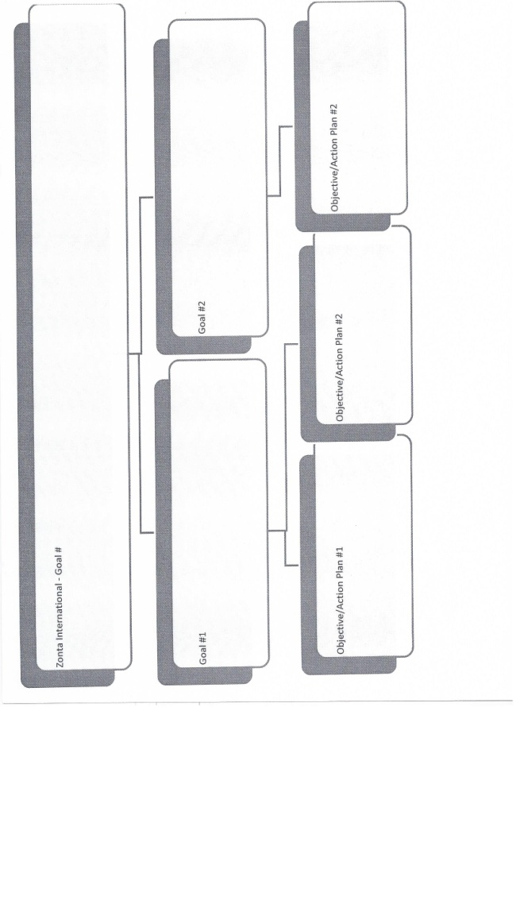
At the district conference, Sandra Cronk, Communications Chair, shared the upgraded international Zonta website. You can access general Zonta information by clicking on the website but more detailed information is accessed by logging in. You can set that up easily on the site (www.zonta.org) by using your email and a selected password. You then have an on-line profile with your club and contact information and you’ll be in the international Zonta directory. On the site, there is information on the upcoming convention, the latest edition of the Zontian as well as recent pertinent news. Forms, such as a template for club bylaws or expense reimbursement, are available as well as Tools, such administering a district conference. From this site you can learn about what our sisters around the world are doing as well as locate another Zontian or club anywhere! Laura Corey

Zonta Club of Jamestown
www.zontajamestown.org
Jamestown@district4.org
PO Box 913 Jamestown,NY 14701

Published November 24, 2017

