**The Zontiana **[](http://zontajamestown.org/wordpress)

**February 1, 2014**

**C:\Program Files\Microsoft Office\MEDIA\CAGCAT10\j0230876.wmfHappy Valentines Day!**

Birthdays: Laura Corey 6

**President’s Corner:**

I cannot believe how quickly time seems to be flying….it must be all the fun we are having.  Our guest speaker, Lt. Col (retired) Theresa Baginski for January’s discussion on “Women in the Military” was amazing.  Thank you Roz.  I know she brought tears to more than just my eyes.  She was very moving.  And LunaFest is just days away on February 1.  A lot of planning has gone into this event and I am so excited to watch the movies and am certain this will become an annual event.  Our first committee planning meeting for Tour de Zonta will be in February (date to be confirmed shortly).  Thank you to all who have signed up as committee chairs or volunteers.  Also, please mark your calendars and plan to attend our joint program with AAUW on Friday, March 7th.  An awesome menu has been planned with another moving speaker to be presenting.  Lastly, thank you all for working hard to sell calendars, we exceeded last year’s sales and this ensures we have a strong budget to support all of our projects and requests.  See you at our February meetings (5th and 19th) and at LunaFest.

Peace to you,

Bonnie

**Upcoming events:**

February 1, 2014 Luna fest @ The Jackson Center 6p-12a

February 5 Board & Business Meeting

February 19 Program-Advocacy

March 7 AAUW Collaborative Event

March 8 International Women’s Day/Rose Day

March 19 Program-Membership Party

**Program**: The February program was entitled,” Women in the military”. Presenting was Lt. Col (retired) Theresa Baginski.  She is an Associate Professor of Spanish at JCC. Mrs. Baginski shared her experiences over 28 years including a deployment to Afghanistan. It was fascinating with many personal insights into the role women play both historically and currently in the Army. Many opportunities were afforded to her and she completed a very rewarding military career. 

**Community Activites:**

**Persell Middle School Students Use Sewing Skills to Help Lily’s Hope**

Cathy Panepianco, JPS Communication Coordinator

[Jamestown, NY] – Persell Middle School students in Marcy Miller’s Family and Consumer Science classes helped out their local community by creating pillows that will help make Lily’s Hope patients more comfortable during chemotherapy.

“All grade levels helped out with this project,” said Mrs. Miller. “I was so thrilled to see the students get so excited to help out. They worked as a team, fifth through eighth grades, to create these comfort pillows. We talked about cancer and the struggles that patients go through and how a kind act like this can make a huge difference.”

Students first created personalize pillows where they learned how to follow directions, hand sew and use a sewing machine. They also learned more about how clothing is made and the difference between cheaper and more expensive fabric. Then, they created the comfort pillows for Lily’s Hope with their newly honed skills.

“It is really good to give back to the community and help other people out,” said Persell Middle School eighth grader Alyson Edwards. “By creating these pillows, we are giving a little comfort to someone who is going through a difficult time and it makes you feel good to help out.”

The Zonta Club helps sponsor the local Lily’s Hope, which is a free service to woman who may lose their hair to a disease such as cancer. They provide wigs, hats and turbans free of charge.

“It’s so sweet to see all of the work the students put into the pillows,” said Zonta representative Rosie Papalia. “It’s so enjoyable to see young people helping out their local community and it will make such a big difference to the patients’ journey.”

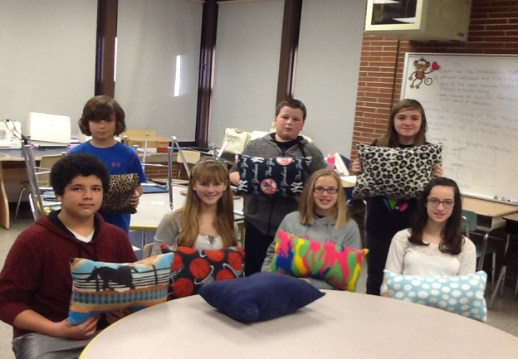

Upcoming Event: Women In Leadership award

We need each of our Zonta members to look outside in our vast community and select a woman who would be an outstanding representative for the Women In Leadership award.

She cannot be a member of Zonta but is someone who has given her time to helping women and her community.  It might be through her work or community service.

Please submit names, addresses, emails, phone numbers with a description of why you feel this person should be selected.

Submit your nominations to Roz by February 15th!

**Spring Workshops:**

|  |  |  |
| --- | --- | --- |
| |  |  | | --- | --- | | |  | | --- | |  | | |
| |  |  |  | | --- | --- | --- | | |  |  | | --- | --- | | |  | | --- | |  | | | |
| |  |  |  |  |  |  | | --- | --- | --- | --- | --- | --- | | |  |  | | --- | --- | | |  | | --- | |  | |  |  |  |  | | --- | --- | --- | | |  |  | | --- | --- | | |  | | --- | | **Workshop Fee (includes Continental Breakfast and Lunch)**  Early Bird . . . $45 First Timer Discount . . . $5 After Early Bird Registration Date . . . $50 | | | | |
| |  |  |  |  |  |  |  |  |  |  |  |  |  |  |  | | --- | --- | --- | --- | --- | --- | --- | --- | --- | --- | --- | --- | --- | --- | --- | | |  |  |  |  | | --- | --- | --- | --- | | |  |  |  | | --- | --- | --- | | |  | | --- | |  | | **Area 1 and 2** April 26, 2014  **Hosted by Zonta Club ofOakville** The Glenerin Inn 1695 The Collegeway Mississauga ON  **Early Bird Registration by April 5th** **Accommodations:** The Glenerin Inn (877) 991-9971 | | | | |  |  |  |  | | --- | --- | --- | --- | | |  |  |  | | --- | --- | --- | | |  | | --- | |  | | **Area 3 and 4**  April 5, 2014  **Hosted by** **Zonta Club ofRochester** RIT  Conference Center 5257 West Henrietta Rd Henrietta NY  **Early Bird Registration by March 7th**  **Accommodations:** RIT Conference Center (585) 359-1800 | | | | |  |  |  |  | | --- | --- | --- | --- | | |  |  |  | | --- | --- | --- | | |  | | --- | |  | | **Area 5 and 6** April 12, 2014  **Hosted by** **Zonta Club of****Three Rivers Pittsburgh North** Frescos 1 Wexford Square Wexford PA  **Early Bird Registration by March 30th** **Accommodations:** Four Points by Sheraton 910 Sheraton Drive Mars PA 16046 (724) 776-6900 | | | | |
| **In The News:**  **Club Provides Library Materials on Women’s Issues**  JAMESTOWN -- Prendergast Library has added new books about pregnancy, birth, infant care, and other issues of special interest to women with support from Zonta Club of Jamestown.  “Women will be able to use these materials to access current information that will affect their well-being and that of their children,” said Director Tina Scott.  “We are so excited to work with the library and provide titles that can help women in our community,” according to Julia Derkovitz, liaison between Zonta Club of Jamestown and Prendergast Library.  Zonta’s support represents a donation of $675 from the second annual Mother-Daughter Charity Softball Game held in July at Sharpe Field at the Chautauqua Institution. Each year the softball teams raise money for charity, and Zonta Club of Jamestown benefitted from proceeds in 2013, toward its mission of advancing the status of women locally and worldwide.“We would like to extend our appreciation to Cesca Koron and Jenny Rappole for their thoughtfulness and presentation of this gift,” said Club President Bonnie DeJoy.  When Zonta members decided to dedicate the gift toward providing new books for women and adolescent girls at Prendergast Library, part of their donation was used to update materials on pregnancy, birth and infant care they had provided to the library in 2011. Subjects include breastfeeding and healthy eating while expecting.  Other books were also added about challenges facing young teen-age girls as they mature, women’s health concerns like breast cancer, and career topics such as job searching, training, networking, and advancement.  For area residents who would like to borrow the new books, there is no charge for a library card, and the library is open 69.5 hours a week for browsers’ convenience. The new materials are on display, and a list of titles is available in print or online. |

  Zonta members also hope to explore programming with the library on women’s issues.

To learn more about the Zonta Club of Jamestown, see [www.ZontaJamestown.org](http://www.ZontaJamestown.org) or visit its Facebook page.

Prendergast Library is located at 509 Cherry St., Jamestown. For information, call 484-7135.

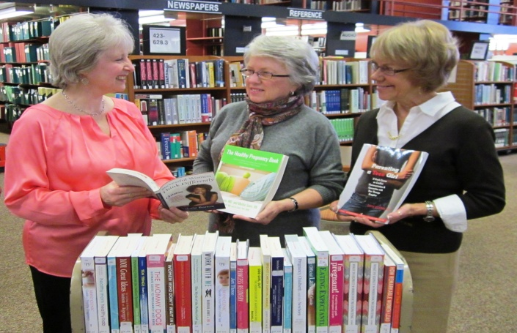

**Tina Scott, director of Prendergast Library, left, shows new books purchased with a grant from Zonta Club of Jamestown to club members Sylvia Stenander, center, and Mary Rappole, right.**

Zonta Club of Jamestown

P.O. Box 913

Jamestown, New York 14701

zontajamestown.org

Jamestown@zontadistrict4.org