The Zontiana
December 1, 2013
Birthdays: Karen Dolce 2nd, Liz Frederick 18th, Julia Derkovitz 25th!
President’s Corner:
OK, we are off to a great start for this new year but first I would like to congratulate Shauna as our newest Zontian of the Year. Thank you for your leadership and inspiration for all Zontians and especially from me for guidance as I work to fill your shoes. I am excited about our upcoming programs, including our collaborative program with AAUW in March (more details to follow shortly). We have a lot going on in December, including ringing the bell for the Salvation army, the TEAM holiday party and our own holiday party, complete with an anticipated delicious meal from Chef Dave. We will start pulling together the committee for the Bike Rally in January and getting ready for Lunafest. But until then please remember to wear orange and spread the word that “Zonta Says No to Violence Against Women”.
Peace to you and Happy Thanksgiving,
Bonnie
Upcoming events:
Dec 3, 2013 LUNAFEST planning Meeting at LSS 5:30pm -Any ? Contact Jody Shely
December 4 Board and Business meeting
December 18 Holiday Party at LSS
Advocacy: The 16 Days of Activism have begun-Did You Pledge to Say NO??
Reminders: Check out our website for the latest pictures and upcoming events! Be sure to notify Rosie, Cheryl Van Riper or Megan about any updates to assure we keep it the best and most informative website!!

In The News:
JAMESTOWN, NY: At a recent meeting of the Breast Cancer Support Group of Jamestown, the group presented a check to the Zonta Club of Jamestown in the amount of $1,000 to be designated toward "Lily's Hope."

At the same meeting, a check for $1,000 was also presented to Karl Sisson for Links Charity to go toward the WCA Women's Imaging Department.

"Lily's Hope," sponsored by the women of Zonta, is located at the Cancer Treatment Center at Jones Memorial Hospital of Jamestown. Women who live in or are being treated in Chautauqua County for a medical diagnosis where they are losing their hair can get a wig, cap, hat or turban FREE of charge. If you, or someone you know is in need of a wig, please call the Cancer Treatment Center at 664-8670 for an appointment.

PICTURED: Breast Cancer Support Group members Jen Rader (far left) and Jen Restivo (far right) present $1,000 donation to Zonta Club members (L-R Center) Ellen Munella and Margie Fuchs.
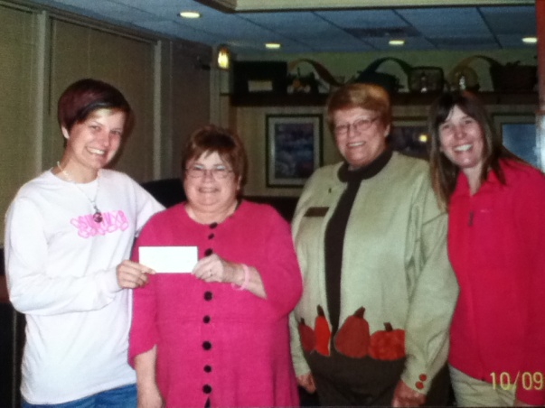

ZONTA TV RAFFLE DONATION TO C.A.P.

Jamestown, NY: The Zonta Club of Jamestown recently held a TV Raffle of an LG 42" Flat Screen LCD TV, with all proceeds going to the 'Zonta International Strategies to end Violence Against Women' (ZISVAW) fund. Originally donated to the Zonta Club for raising funds, the TV was won by Zonta's own Marcia Bliss, a long time member of the club. Marcia Bliss, who also serves as President of the Board of Directors for the Child Advocacy Program (CAP) in Jamestown, announced she has donated the TV toward CAP's Diamond Dinner Auction. The Diamond Dinner is CAP's signature fundraiser to be held April 26th, 2014.
About $595 was raised with the TV Raffle. Earlier this year the Zonta Club hosted a play at the Spire Theater at which $870 was raised. Together, both fundraising events garnered about $1500 which will go toward the ZISVAW fund for their international projects. Zonta International sponsors several programs to end violence against women, of which are: a 'Global Partnership on Edutainment for Social Change,' 'Safe Cities in Honduras' and 'Empowering Women in Rural Samoa to Combat Violence.' More about these initiatives can be found at www.Zonta.org.

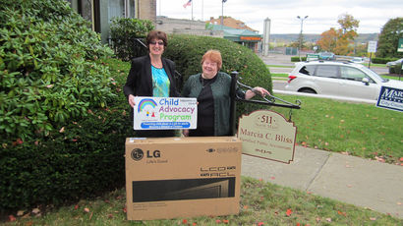

Zonta Club of Jamestown
P.O.Box 913
Jamestown, New York 14701
zontajamestown.org
Jamestown@zontadistrict4.org

